ECE 3355 – ELECTRONICS
HOMEWORK #8

Sedra and Smith 8th Ed. Chapters 4 and 18: Problems 4.83, 4.84, 15.44 (Figure 15.23 (b) is on page 1097.)
Problems E8.1, E8.2, E8.3, E8.4 (see below)

E8.1: For the circuit shown below (Figure P3.65 from 4th Edition of Sedra and Smith), solve for and plot the transfer characteristic, v_{O} vs v_{I}, using a piecewise linear diode model for each of the diodes, with V_{f} = 0.6[V], r_{d} = 10[Ω], and I_{s} = 0. Use an input range –15[V] < v_{I} < +15[V].
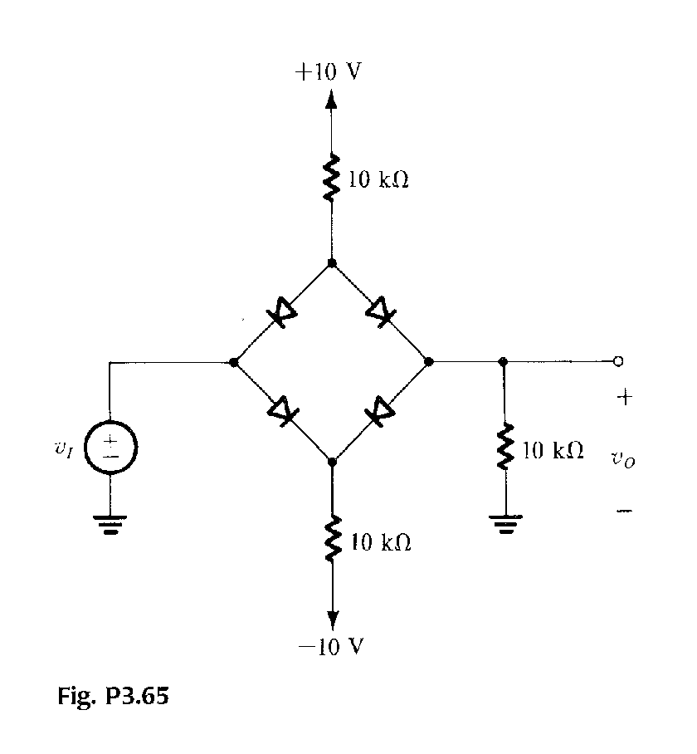

E8.2: Repeat Problem 15.23 from the Sedra and Smith 8th Edition text, but solve using L₊ = 15[V], and L₋ = -8[V].

E8.3: Zener Diode Regulator

For this problem you will need the data sheet labeled “Zener_1N5227B.pdf”, which is available on-line. Note that the data sheet provides values for V_{Z}, which is measured at the current I_{Z}, as well as for the series resistance (called the impedance Z_{ZT}), which is valid at the test current I_{ZT}. For a graphical definition of these terms, see your text (Sedra and Smith 7th Ed., Fig. 4.19).

We want to design a 12 V regulator using a reverse-bias Zener diode. The circuit we will consider is that of Fig. 4.21 in your text, and the load will be 2.2[kΩ]. The supply voltage is 25[V], but it can vary by as much as 10%. You have for your use the diodes listed in the data sheet.

i) Choose one Zener diode to regulate the load voltage to approximately 12 [V]. Based on the information in the data sheet, find V_{ZO} for this diode.
ii) If the Zener current is 25 [mA], find V_{Z}. Then find the current through R, and from that determine a value for R. Use the nominal voltage for the power supply (i.e., 25 [V]).
iii) Find the line regulation.
iv) Now assume that you are fresh out of 1N5242B Zener diodes. What do you do, and how would your answers to the above questions change? In particular, does the line regulation get better or worse, or stay pretty much the same?

E8.4: Design of an ac Voltmeter

Using the ideas discussed in class for an ac voltmeter, design such a device using a “super-duper diode” and op amp filter(s). Your design should satisfy the following specifications.

i) The output of the meter should be a dc signal proportional to the amplitude of a sinusoidal signal at the input. However, we also want some dc gain (i.e., amplification of the signal amplitude); this must be at least 20 dB.
ii) The minimum operating frequency of your voltmeter should be 100 Hz.
iii) Although the voltmeter output is nominally dc, you may have sinusoidal signals in your output (i.e., ac signals that pass your filter), but any such signal must have a gain of no more than -20 dB.
iv) For reasons that have not been made clear to you, your customer stipulates that you cannot use resistances larger than 10 kΩ, or capacitors larger than 10 μF.

